AI Powered Debt Relief & Financial Recovery Platform Project

Description:
The AI Powered Debt Relief & Financial Recovery Platform is an intelligent web application designed to help individuals manage their debts, improve financial planning, and achieve financial stability. The platform allows users to securely register, track their income, expenses, loans, and EMIs, while providing a centralized dashboard to monitor their overall financial status. Its user-friendly interface makes financial management simple, efficient, and accessible.

The platform uses Artificial Intelligence (AI) to analyze users' financial data and generate personalized debt repayment strategies, budgeting suggestions, and financial insights. It also provides expense tracking, repayment reminders, and visual reports to help users make informed financial decisions. Built using React.js, Node.js, Express.js, and MongoDB, the system ensures secure data management while offering a smart and effective solution for debt relief and long-term financial recovery.
Scenarios
Scenario 1: User Registration
A new user creates an account by entering personal details such as name, email, phone number, and password. After successful registration, the user logs in to access the platform.

Scenario 2: User Login
A registered user logs in securely using their email and password. After authentication, the user is redirected to the dashboard.

Scenario 3: Debt Analysis
The user enters financial details such as income, monthly expenses, loan amount, interest rate, and EMIs. The AI analyzes this information and provides personalized debt repayment strategies and financial recommendations.

Scenario 4: AI Letter Generation
The user provides the required information, and the platform generates a professional debt relief request letter that can be shared with banks or financial institutions.

Scenario 5: Profile Management
The user can view and update personal information, change account details, and securely manage their profile.

Scenario 6: Dashboard Monitoring
The dashboard displays a summary of the user's financial information, debt status, AI recommendations, and repayment progress, helping users make informed financial decisions.

Technical Architecture:
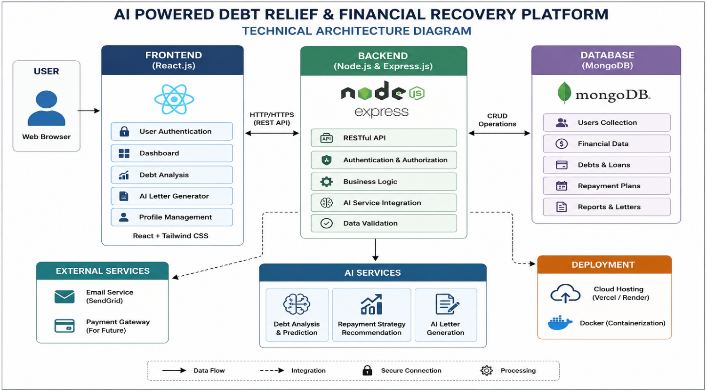
Description: The AI Powered Debt Relief & Financial Recovery Platform utilizes a modular three-tier architecture to provide intelligent debt analysis, financial recovery planning, and AI-assisted debt negotiation support. The frontend is developed using React.js with Tailwind CSS, offering a responsive and user-friendly interface. The Node.js and Express.js backend handles authentication, business logic, API routing, and communication with the database. MongoDB securely stores user information, debt records, repayment plans, and generated reports. AI services are integrated to analyze financial data, recommend personalized repayment strategies, and generate professional debt negotiation letters. The application is deployed using cloud platforms such as Vercel (frontend) and Render (backend), ensuring secure and scalable access.

Pre-requisites:
• React.js and Tailwind CSS Fundamentals
• Node.js and Express.js Development
• MongoDB Database Knowledge
• REST API Development
• JavaScript (ES6+) Programming
• AI API Integration (OpenAI/Groq/Gemini or the AI service used)
• Git and GitHub Version Control
• Deployment using Vercel and Render
• VS Code Development Environment
Project Workflow:
Milestone 1: Project Architecture & Environment Setup
- Activity 1.1: Design the overall architecture of the Debt Relief Platform, defining interactions between the frontend, backend, database, and AI services.
- Activity 1.2: Configure the development environment by installing React.js, Node.js, Express.js, MongoDB, and required dependencies.
- Activity 1.3: Set up MongoDB collections for users, debts, repayment plans, and financial reports.
- Activity 1.4: Integrate the selected AI service for debt analysis and financial recommendation generation.

Milestone 2: Backend Development

Activity 2.1: Develop REST APIs for user authentication, debt management, repayment plans, and financial records.

Activity 2.2: Implement business logic for debt analysis, repayment calculations, and AI-powered recommendations.

Activity 2.3: Connect the backend with MongoDB to perform secure CRUD operations.

Milestone 3: AI Integration

Activity 3.1: Integrate AI services to analyze user financial data and generate personalized debt recovery strategies.

Activity 3.2: Develop AI-powered debt negotiation letter generation.

Activity 3.3: Implement AI-based financial insights and repayment suggestions.

Milestone 4: Frontend Development

Activity 4.1: Design a responsive user interface using React.js and Tailwind CSS.

Activity 4.2: Develop pages for user registration, login, dashboard, debt management, repayment tracking, AI recommendations, and profile management.

Activity 4.3: Connect the frontend with backend APIs to display real-time financial data and AI-generated results.

Milestone 5: Testing & Deployment

Activity 5.1: Perform unit testing, integration testing, and user acceptance testing to ensure application reliability.

Activity 5.2: Deploy the frontend using Vercel and the backend using Render.

Activity 5.3: Verify end-to-end functionality, database connectivity, and AI response accuracy before final release.

Milestone 6: Conclusion
The AI Powered Debt Relief & Financial Recovery Platform provides an intelligent and user-friendly solution for individuals facing financial challenges. By integrating artificial intelligence with modern web technologies, the platform helps users analyze their debts, receive personalized repayment strategies, and generate professional debt negotiation letters. This reduces the complexity of financial planning and enables users to make informed decisions for effective debt management.

Milestone 1: Project Architecture and Environment Setup
In this milestone, the overall architecture of the AI Powered Debt Relief & Financial Recovery Platform is designed, and the required development environment is configured. The frontend, backend, database, and AI components are planned to work together for efficient debt analysis and financial recovery.
Activity 1.1: Set Up the Development Environment
Step 1: Install Node.js and Visual Studio Code.
Step 2: Create the React frontend and Node.js/Express backend.
Step 3: Configure the MongoDB database and install the required dependencies.
Step 4: Integrate the AI API and verify that the application runs successfully.

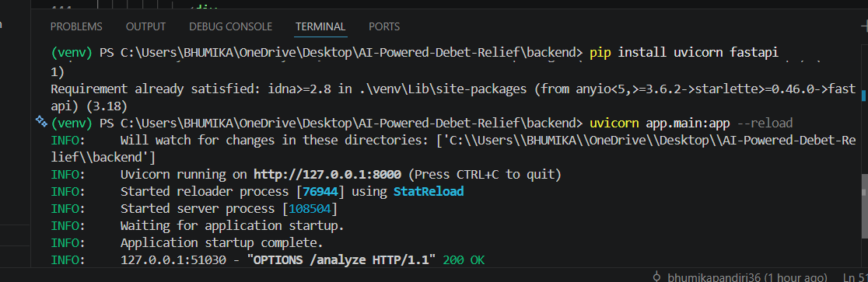

Step 2 – Open the Project in Visual Studio Code
Open Visual Studio Code and load the AI Powered Debt Relief & Financial Recovery Platform project folder. Verify that both the frontend and backend folders are available and the project structure is correctly organized before starting development.
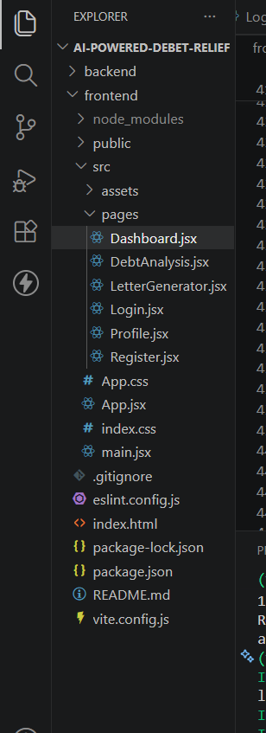

Step 3 – Install Project Dependencies
Open the terminal and install the required packages.
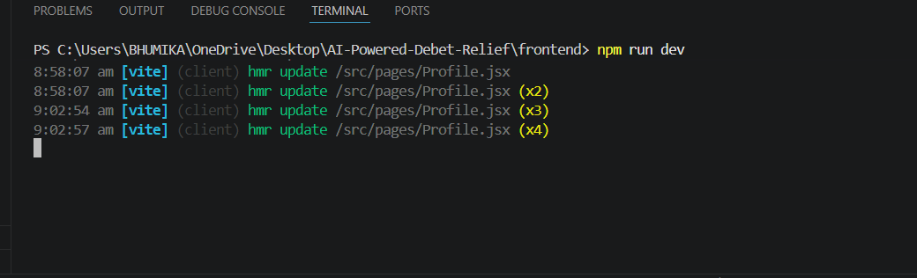

- Step 4 — API Key: Now give a “Display Name” and “Expiration” is optional, and Click on “Submit”. The you will get your API key, Copy it immediately and store it in a safe place you will not be able to view it again after closing the dialog.

- Step 5 — Add the Key to Your Project: Create a .env file in the root of your project directory (if it does not already exist) and paste the key as shown below:
GROQ_API_KEY=your_copied_api_key_here
- Step 6 — Verify the Key is Loaded: The app.py file loads this key automatically at startup using python-dotenv: from dotenv import load_dotenv load_dotenv()
client = Groq(api_key=os.environ.get("GROQ_API_KEY"))
- Important — Never Commit Your API Key: Add .env to your .gitignore file to prevent accidentally pushing the key to a public repository:
.env

Activity 1.2: Research and Select the Appropriate Generative AI Model
Here are the things that needed to research to select a best model for the project:
- Understand the Project Requirements: Review the specific needs of the CaptionAI application, focusing on the types of content it will generate (captions, hashtags, and calls-to-action across Instagram and LinkedIn).
- Explore Groq’s Model Documentation: Visit the Groq documentation to examine the available LLM models, including their functionalities, context windows, speed, and limitations.
- Evaluate Model Performance: Compare models based on response quality, generation speed, and relevance to social media copywriting tasks.
- Select the Optimal Model: Choose llama-3.3-70b-versatile for its balance of creative output quality and generation speed, set with a temperature of 0.8 and max_tokens of 2048 for rich, varied captions.

Activity 1.3: Define the Architecture of the Application
- Draft an Architectural Diagram: Create a visual representation of the application architecture, including components like the frontend (HTML, CSS, JavaScript), Flask backend, and Groq API integration.
- Detail Frontend Functionality: Outline how users interact with the application entering product/campaign information, selecting a platform (Instagram or LinkedIn), and choosing a tone (Professional, Casual, or Promotional).
- Outline Backend Responsibilities: Specify how the Flask backend handles incoming POST requests to /generate, validates and sanitizes user input, builds a structured prompt, and communicates with the Groq API.
- Describe AI Integration Points: Define how the backend constructs prompts using TONE_DESCRIPTIONS and PLATFORM_TIPS dictionaries, calls the Groq API, parses the JSON response via extract_json(), and returns structured results to the frontend.

Activity 1.4: Set Up the Development Environment
- Install Python and Pip: Ensure Python 3.8+ is installed on your machine along with pip for dependency management.
- Create a Virtual Environment: Set up a virtual environment using venv to isolate project dependencies:
D:\projects>python -m venv myenv
D:\projects>"d:\projects\venv\Scripts\activate"
(myenv) D:\projects> pip install -r requirements.txt
- Install Flask: Use pip to install Flask:
(myenv) D:\projects> pip install Flask==3.0.3
- Install Groq SDK: Install the Groq Python library to interact with the Groq API:
(myenv) D:\projects> pip install groq==0.11.0
- Install python-dotenv: Install dotenv support for secure API key management:
(myenv) D:\projects> pip install python-dotenv==1.0.1
- Configure the API Key: Create a .env file in the project root and add your Groq API key:
GROQ_API_KEY=your_groq_api_key_here
- Set Up Application Structure: Create the project directory structure including folders for templates, static files (CSS, JS), and main application files (app.py, requirements.txt, run_public.py).
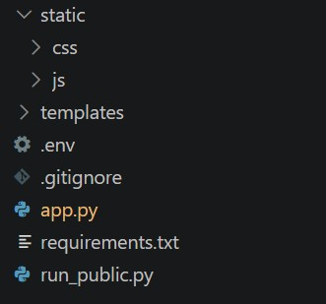

Milestone 2: Core Functionalities Development
Activity 2.1: Develop Core Platform Features
Implement the core functionalities of the AI Powered Debt Relief & Financial Recovery Platform to help users manage debts efficiently.
- User Authentication: Enable secure user registration and login.
- Debt Analysis: Allow users to enter financial information and receive AI-based debt analysis and repayment recommendations.
- AI Letter Generator: Generate professional debt negotiation letters based on user financial details.
- Profile Management: Allow users to view and update their profile information.

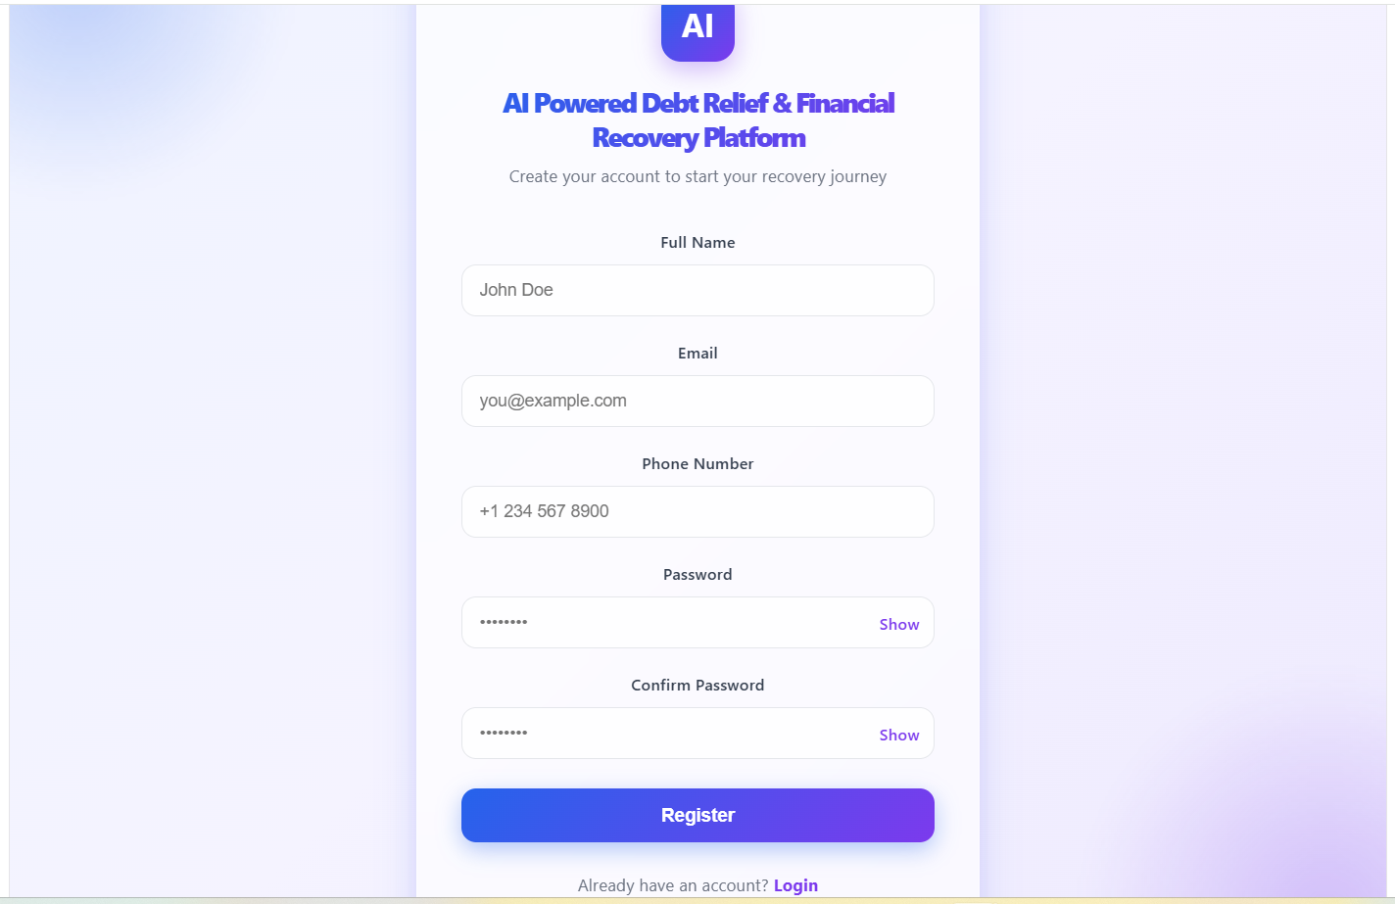

Milestone 3: Backend Application Development
Milestone 3 focuses on developing the core backend logic of the AI Powered Debt Relief & Financial Recovery Platform. In this phase, REST APIs are created to handle user authentication, debt analysis, AI-powered financial recommendations, debt letter generation, and profile management. The backend processes user requests, communicates with the MongoDB database, and returns appropriate responses to the frontend.
Activity 3.1: Develop the Main Backend Logic
Define the Core API Routes
Create the backend routes to perform the following operations:
- User Registration – Register new users.
- User Login – Authenticate users securely.
- Debt Analysis – Analyze financial information and generate AI-based repayment recommendations.
- AI Letter Generator – Generate professional debt negotiation letters.
- Profile Management – Retrieve and update user profile information.
Process User Requests
- Receive financial details from the frontend.
- Validate user input.
- Store and retrieve data from the MongoDB database.
- Generate AI-powered financial recommendations and debt relief letters.
@app.route("/generate", methods=["POST"])
def generate():
data = request.get_json()
product_info = data.get("product_info", "").strip()
platform = data.get("platform", "instagram").lower()
tone = data.get("tone", "professional").lower()
if not product_info:
return jsonify({"error": "Product information is required."}), 400
if len(product_info) > 2000:
return jsonify({"error": "Input too long. Please keep it under 2000 characters."}), 400
try:
prompt = build_prompt(product_info, platform, tone)
chat_completion = client.chat.completions.create(
messages=[
{
"role": "system",
"content": "You are a social media content expert. Always respond with valid JSON
only, no markdown formatting."
},
{
"role": "user",
"content": prompt
}
],
model="llama-3.3-70b-versatile",
temperature=0.8,
max_tokens=2048,
)
response_text = chat_completion.choices[0].message.content
result = extract_json(response_text)
# Validate structure
if not all(k in result for k in ["captions", "hashtags", "ctas"]):
raise ValueError("Invalid response structure from AI")
return jsonify({
"success": True,
"captions": result["captions"],
"hashtags": result["hashtags"],
"ctas": result["ctas"],
"platform": platform,
"tone": tone
})
except ValueError as e:
import traceback
traceback.print_exc()
return jsonify({"error": f"Failed to parse AI response: {str(e)}"}), 500
except Exception as e:
import traceback
traceback.print_exc()
return jsonify({"error": f"Generation failed: {str(e)}"}), 500

Set Up Route Handlers for Each Feature:
- For the /generate route, implement logic that reads product_info, platform, and tone from the incoming JSON body using request.get_json().
- Apply input validation: return a 400 error if product_info is empty or exceeds 2000 characters.
- Route AJAX requests from the frontend to the /generate endpoint, which processes data and returns a JSON response.

Define Prompt Engineering Helpers:
- TONE_DESCRIPTIONS dictionary: maps professional, casual, and promotional tones to detailed copywriting instructions embedded in the prompt.
TONE_DESCRIPTIONS = {
"professional": "formal, authoritative, and business-oriented. Use clear, concise language that
conveys expertise and credibility.",
"casual": "friendly, conversational, and relatable. Use informal language, emojis, and a warm tone
that feels personal.",
"promotional": "exciting, persuasive, and action-driven. Use power words, urgency, and compelling
offers to drive engagement."
}

- PLATFORM_TIPS dictionary: maps instagram and linkedin to platform-specific content guidelines (character limits, style expectations).
PLATFORM_TIPS = {
"instagram": "optimized for Instagram — visually descriptive, emotionally engaging, with strong
visual storytelling. Max 2200 characters.",
"linkedin": "optimized for LinkedIn — professional insights, value-driven, thought leadership
style. Max 3000 characters."
}

- build_prompt(): assembles a structured prompt string from the product info, selected platform tip, and tone description, instructing the model to return strictly valid JSON.
def build_prompt(product_info: str, platform: str, tone: str) -> str:
tone_desc = TONE_DESCRIPTIONS.get(tone, "engaging")
platform_tip = PLATFORM_TIPS.get(platform, "social media")
return f"""You are an expert social media content strategist and copywriter.

Integrate the Groq AI Responses in Each Function:
- Call client.chat.completions.create() with a system message enforcing JSON-only responses and a user message containing the assembled prompt.
- extract_json(): a robust parser that first attempts direct json.loads(), then strips markdown code fences (```json blocks), and finally uses a regex to locate a raw JSON object ensuring reliable parsing across model response variations.
def extract_json(text: str) -> dict:
"""Extract JSON from LLM response, handling markdown code blocks."""
# Try direct parse first
try:
return json.loads(text)
except json.JSONDecodeError:
pass
# Try extracting from markdown code block
match = re.search(r'```(?:json)?\s*([\s\S]*?)```', text)
if match:
try:
return json.loads(match.group(1).strip())
except json.JSONDecodeError:
pass
match = re.search(r'\{[\s\S]*\}', text)
if match:
try:
return json.loads(match.group(0))
except json.JSONDecodeError:
pass
raise ValueError("Could not extract valid JSON from response")

- Validate that the parsed result contains all three required keys — captions, hashtags, and ctas — before returning it to the frontend.
- Home route: / → renders index.html/generate (POST) → accepts JSON, returns {success,captions, hashtags, ctas, platform, tone}

Milestone 4: Frontend Development
Milestone 4 focuses on developing a user-friendly and visually appealing interface for CaptionAI. This involves designing a glassmorphism-style layout with responsive HTML and CSS to enhance usability, and creating dynamic content rendering with vanilla JavaScript to display AI-generated captions, hashtags, and CTAs based on user interactions.

Activity 4.1: Designing and Developing the User Interface
Set Up the Base HTML Structure:
- Develop the main HTML file (index.html) as the single-page interface, including a header with the CaptionAI brand logo and tagline, an input section, and a results section.
- Use semantic HTML elements to keep the structure organized and ensure the interface is accessible for all users.
- Integrate Font Awesome icons for platform indicators and result section headings, and Google Fonts (Inter) for clean typography.

Design a Responsive Layout Using CSS:
- Create a CSS stylesheet (static/css/style.css) implementing a dark glassmorphism aesthetic with animated background blobs (blob-1, blob-2, blob-3) for visual depth.
- Use flexbox and grid layouts to organize the results into a two-column structure (captions on the left, hashtags and CTAs on the right).
- Add media queries to ensure the layout adapts across desktop, tablet, and mobile screen sizes.

Create Separate UI Components for Each Output Type:
- Caption Cards: individual cards per caption, each with a one-click copy-to-clipboard button that provides visual feedback (checkmark + green highlight for 2 seconds).
- Hashtag Chips: rendered as pill-shaped chip elements inside a glass card, with automatic # prefix validation.
- CTA List: displayed as a clean unordered list inside a separate glass card with a bullhorn icon header.

Activity 4.2: Creating Dynamic Content Rendering with JavaScript
Handle Form Submission Asynchronously:
- Attach a submit event listener to the generator form that prevents default form submission and sends the data as a JSON POST request to /generate via the Fetch API.
- During loading, disable the submit button and show an animated CSS loader in place of the button text and arrow icon.

Render Results Dynamically:
- Implement the renderResults(data) function in main.js, which dynamically creates and injects DOM elements for captions, hashtags, and CTAs into their respective containers.
- After rendering, automatically smooth-scroll the viewport to the results section using scrollIntoView().

Restore UI State After Generation:
- In the finally block of the async handler, re-enable the submit button and restore the original button text and icon regardless of success or failure.

Milestone 5: Deployment
In Milestone 5, the focus is on deploying the CaptionAI application first locally to verify correct operation, and then publicly via Ngrok to share the app over a secure, accessible URL. This involves configuring the server environment, managing dependencies, and launching the app for real-world use.

Activity 5.1: Preparing the Application for Local Deployment
Set Up a Virtual Environment:
- Open a New Terminal
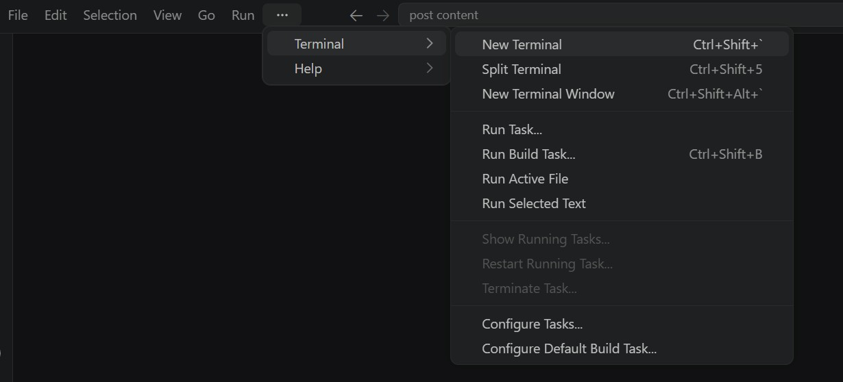
- Then open “Command Prompt”
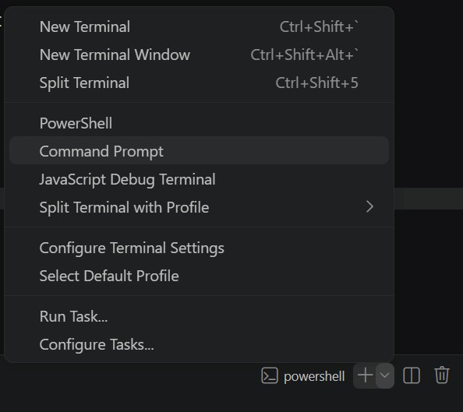

- Create and activate a virtual environment, then install all required dependencies from requirements.
D:\projects>python -m venv myenv
D:\projects>"d:\projects\venv\Scripts\activate"
(myenv) D:\projects>pip install -r requirements.txt

Configure Environment Variables:
- Create a .env file in the project root and add your Groq API key. The app loads this automatically using python-dotenv at startup: GROQ_API_KEY=your_groq_api_key_here

Activity 5.2: Local Testing and Verification
Start the Flask Development Server:
- Run the application locally using:
(myenv) D:\projects>python app.py
- Once running, open a browser and navigate to “http://127.0.0.1:5050” to access the app.
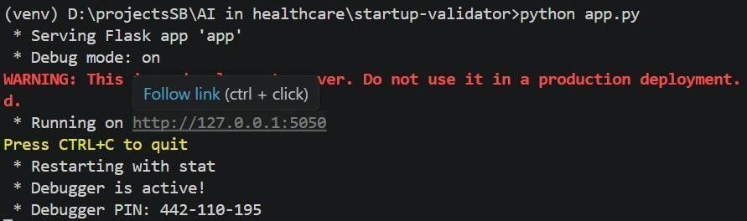
- Interact with the caption generator test all three tones (Professional, Casual, Promotional) and both platforms (Instagram, LinkedIn) to verify the AI responses are correctly generated, parsed, and rendered.

Activity 5.3: Public Deployment via Ngrok
Ngrok creates a secure tunnel from a public URL to your local Flask server, making the app accessible from anywhere without a cloud hosting provider.
Install Ngrok and pyngrok:
- Install the pyngrok Python wrapper, which manages Ngrok programmatically within your Python project:
D:\projects>pip install pyngrok
- Download and install the Ngrok client from https://ngrok.com/download.
- Click on “Microsoft Store Installer”.
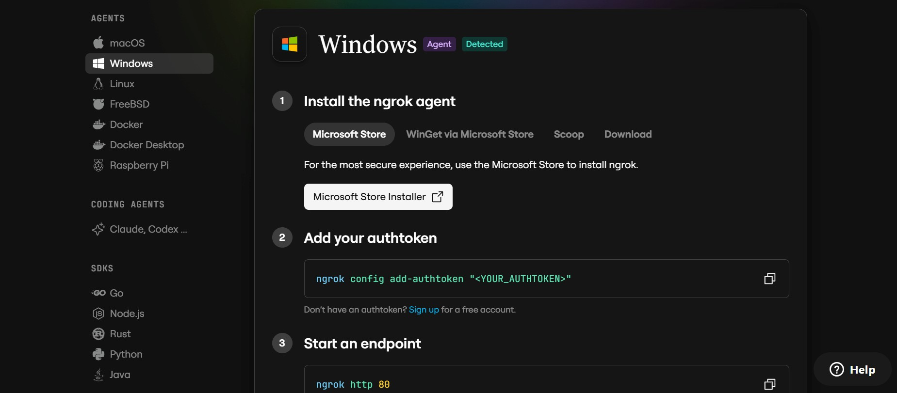
Configure Your Ngrok Authtoken:
- Sign up at ngrok.com and copy your authtoken from the Ngrok dashboard.
- The run_public.py script sets the authtoken automatically using:
D:\projects>ngrok.set_auth_token("YOUR_NGROK_AUTHTOKEN")
- Replace the TOKEN value in run_public.py with your own Ngrok authtoken before running.

Run the Public Deployment Script:
- Instead of running app.py directly, launch run_public.py to start both the Ngrok tunnel and the Flask server:
D:\projects>python run_public.py
- The script opens an HTTP tunnel on port 5000 and prints the live public URL in the terminal:
====================================================== YOUR PUBLIC WEBSITE URL IS LIVE!
URL: https://xxxx-xx-xx-xxx-xx.ngrok-free.app
======================================================
- Share this URL with anyone who can access your CaptionAI app directly from their browser without any installation.

Important Notes:
- debug=False is required in run_public.py to prevent Flask from spawning a reloader process, which would interfere with Ngrok’s tunnel management.
- The public URL changes each time you restart run_public.py (on the free Ngrok plan). For a persistent URL, upgrade to a paid Ngrok plan and configure a reserved domain.
- Ngrok free tier sessions expire after a few hours of inactivity. Restart run_public.py to get a new URL when this happens.

Exploring the Website’s Web Pages:
Home / Generator Page:
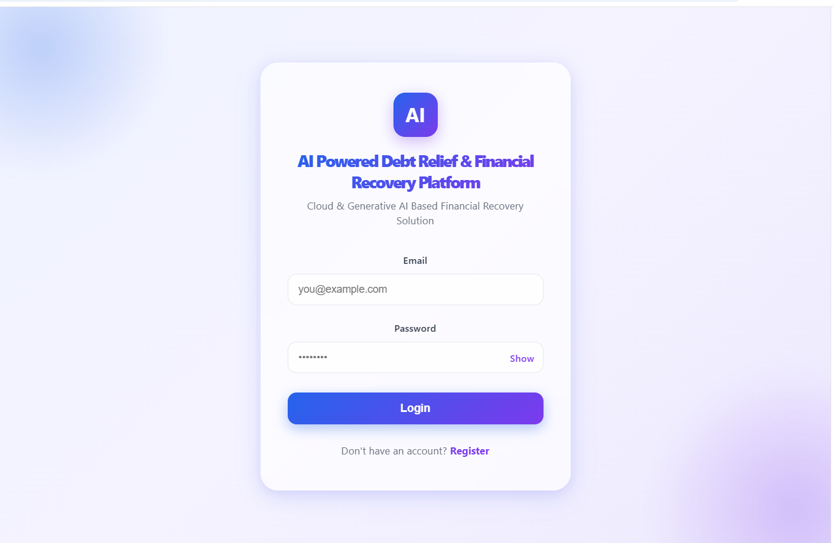

Description: The single-page interface of CaptionAI serves as both the landing page and the generation tool. It features a dark glassmorphism design with animated background blobs, a header displaying the CaptionAI brand (wand-magic-sparkles icon + logo), and a tagline. The main section contains the input form, platform toggle, tone selector, and the AI-generated results panel all on one seamless page.
Input Section:
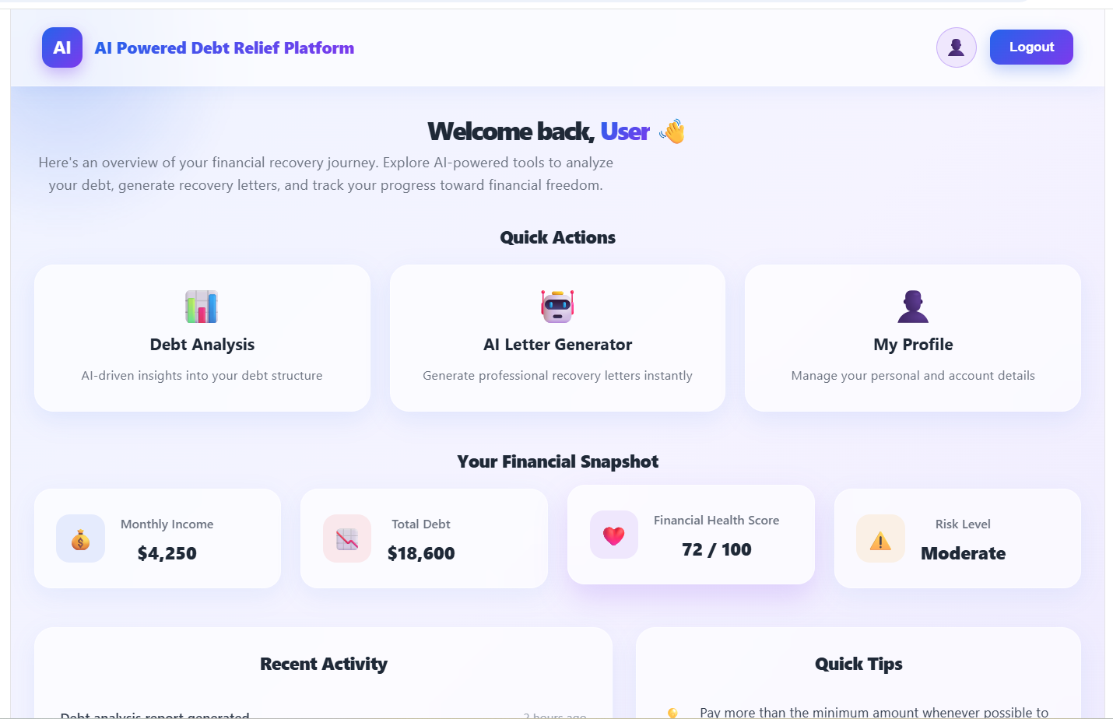

Description: A glass-styled card containing the main generation form. Users enter their product, service, or campaign description in a textarea (up to 2000 characters), select their target platform via a toggle button group (Instagram or LinkedIn), choose their tone of voice (Professional, Casual, or Promotional), and click the Generate Content button. While the AI processes the request, the button transitions to an animated loading spinner.
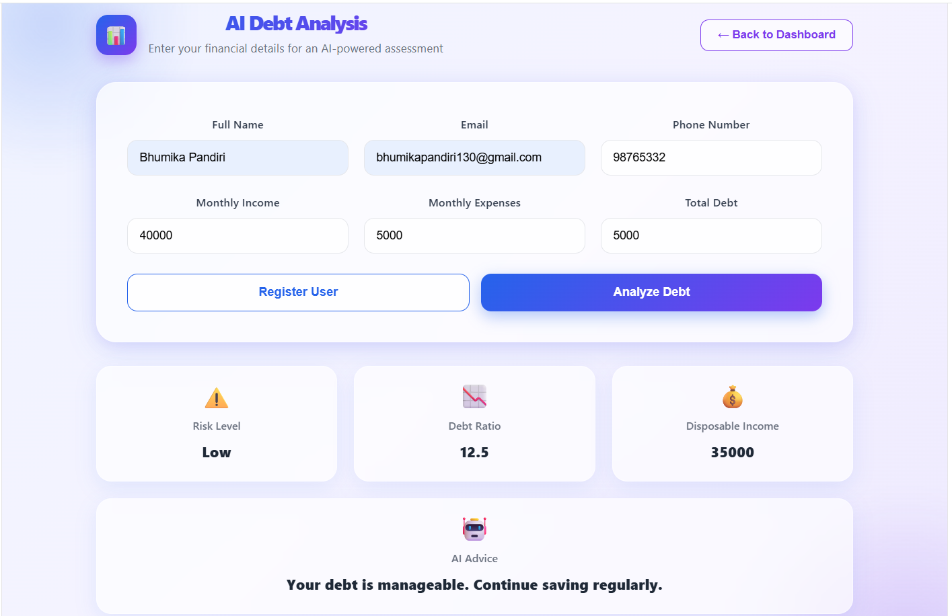
Results Section:
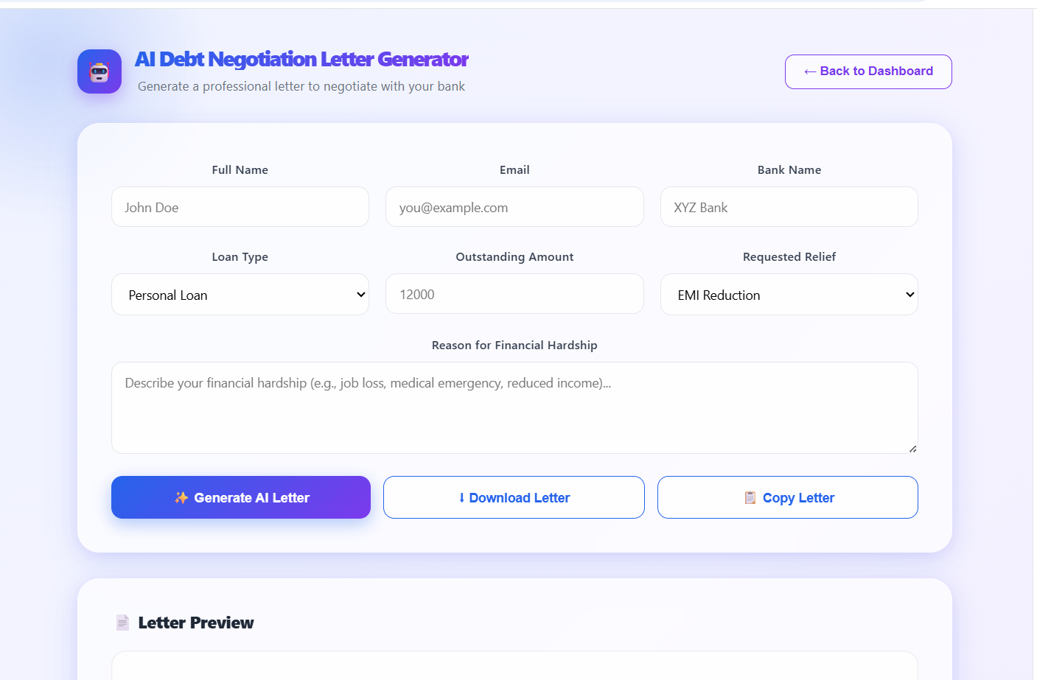
Description: Revealed dynamically after generation, this section displays the AI output in a two-column grid. The left column shows three caption cards, each with the generated caption text and a copy-to-clipboard button. The right column contains two glass cards: one with ten hashtag chips (prefixed with #) and one with three CTA phrases in a list format. The viewport automatically smooth-scrolls to this section upon content generation.
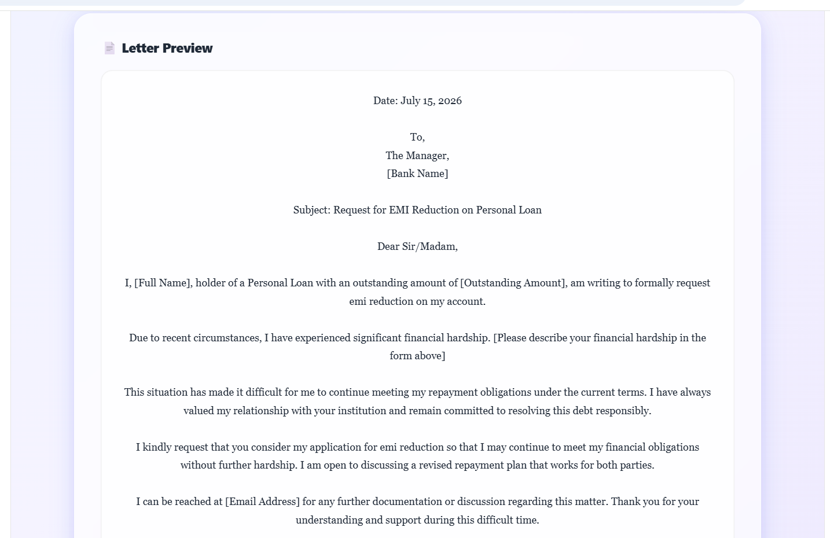

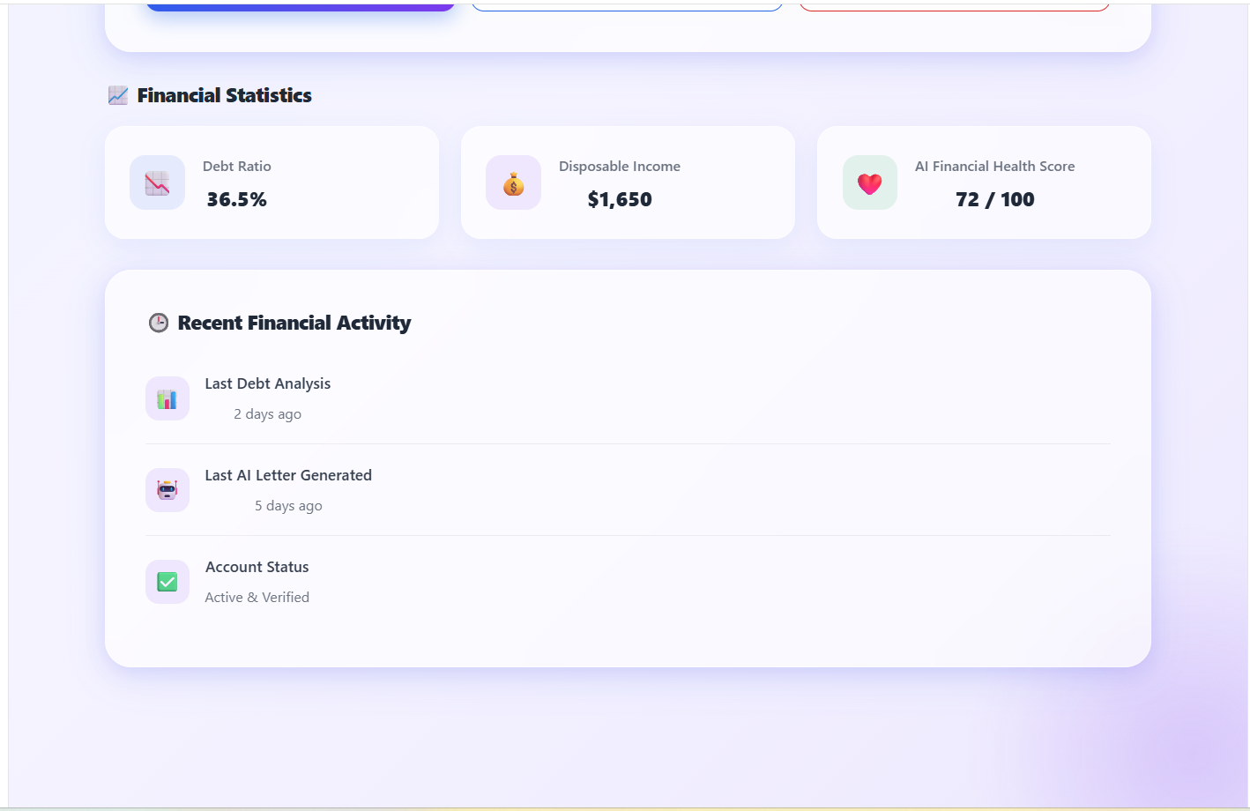
Conclusion:
The backend development of the AI Powered Debt Relief & Financial Recovery Platform was successfully completed by implementing secure REST APIs, user authentication, debt analysis, AI-powered financial recommendations, and debt negotiation letter generation. The backend efficiently processes user requests, communicates with the MongoDB database, and provides accurate responses to the frontend.
The application successfully integrates modern web technologies to deliver a secure, scalable, and user-friendly financial assistance platform. The developed backend forms the foundation of the system, ensuring reliable data management, seamless AI integration, and efficient communication between the frontend and database.

